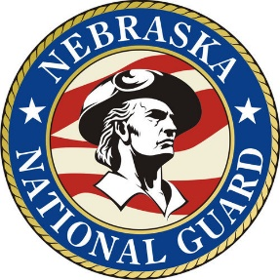
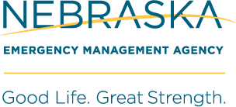
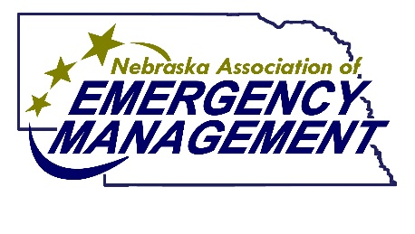
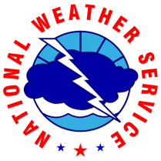

2023 Nebraska Severe Weather Awareness Poster Contest
The springtime severe weather season is quickly approaching and that means it’s time for the annual 2023 Nebraska Severe Weather Awareness Poster Contest. The contest, sponsored by Nebraska Association of Emergency Management, the National Weather Service, the Nebraska National Guard and the Nebraska Emergency Management Agency, is part of the annual Severe Weather Awareness Week effort produced by Emergency Management Directors/Coordinators across Nebraska.
The poster contest is open to all third grade students in Nebraska public and private schools as well as home-schooled students. Teachers are encouraged to have students participate while teaching them about hazards of severe weather in Nebraska. While not specifically designed to promote tornado awareness, tornadoes are the most common theme chosen for posters. Lightning and flooding, which are also products of severe thunderstorms, are also good topic choices.
The first-place winner in the state contest wins a $125 gift card. The second-place winner receives a $100 gift card and the third-place winner receives a $75 gift card. The Nebraska Association of Emergency Management provides the first, second and third place gift card awards. The fourth place poster winner receives a $50 gift card sponsored by the National Weather Service.
Contest rules are as follows:
1. Poster artists must be a third grade pupil in any Nebraska private, public or home school.
2. Entries must be related to the theme of severe weather safety and will be judged on originality, effort and accuracy. The posters should have a clear preparedness/weather safety message included. The slogan is as important as the art. All entries must be on an 11" x 17" sheet of white paper providing a 1-inch border to allow for matting the winning posters. Any medium may be used (crayon, paint, markers, etc.). Only one entry is allowed per pupil and no joint entries (posters by more than one person) will be accepted.
3. Each school is encouraged to conduct the contest. All entries must be received by the local Emergency Management Director/Coordinator on or before Feb. 10, 2023. A list of EM Directors/Coordinators can be found at www.naem.us or www.nema.ne.gov. Remember to allow enough time for mailed items to get where they need to be.
4. Each entry MUST INCLUDE the following information on the back side of the poster:
Student name: _____________________________ Age: ______________________________________
Home address: _____________________________ Home Phone: _______________________________
School: ___________________________________ School address: _____________________________
Nebraska County where school is located: ______________________________________________________

5. Teachers are encouraged to contact the local Emergency Management Director to assist in the selection of the “top three” entries from their school. If the local director is unavailable or unknown, please contact Brian Woldt, Poster Contest Chairman, (308) 324-2070.
6. First, second, third and fourth place winners will be chosen. All winners will be notified by telephone or mail. The four winners and their parents will be invited to the State Capitol in March for the presentation of their awards from NAEM and NWS and be recognized by Nebraska Gov. Jim Pillen.
7. Any questions regarding the 2023 Severe Weather Poster Contest should be directed to the local Emergency Management Director/Coordinator or to Brian Woldt at (308) 324-2070, email brian.woldt@dawsoncountyne.org.
Contest rules and other information can also be obtained at the Nebraska Association of Emergency Management website at www.naem.us or at the Nebraska Emergency Management Agency website at nema.nebraska.gov. Poster judging will be done by representatives of the contest’s sponsors: Nebraska Association of Emergency Management, National Weather Service, Nebraska Emergency Management Agency and Nebraska National Guard.

