G272 Warning Coordination

August 24-25 2022 8a.m. 5p.m. both days
- Course Description
- This course is the latest in the hazardous weather series of courses produced in partnership with the National Weather Service (NWS). Every year, the United States experiences more severe weather than any other country in the world. In order to reduce deaths, injuries, and property losses, emergency managers must work closely with the NWS and the news media to provide effective warnings that can be received and understood by people at risk. This course is intended to help facilitate that process. Course topics include: The Social Dimensions of Warning Response; Developing Effective Warning Messages; Developing an Effective Community Warning Process; and Working with the News Media to Create a Weather Warning Partnership. In addition to lecture and discussion, the course includes case studies, exercises, and an opportunity for interaction with representatives of the local news media.
- Course Objectives
- Predict how people in the community may respond to different types of warnings based on certain social factors.
- Develop a hazardous weather warning message based on a specific event and the threat it poses to the community.

Where:
Nemaha County EOC
601 J St.
Auburn, NE 68305

- Propose improvements to a community’s warning system based on identified breakdowns in coordination and communication.
- Develop warning messages for a given scenario that are targeted for delivery by a particular media type.

- Develop a warning coordination and communication strategy for a given scenario

Course contact;
Renee Critser 402-274-2552
nemahaema@windstream.net Course Contact: Renee Critser

There is no fee to attend this course.
- Class is limited to 30 students
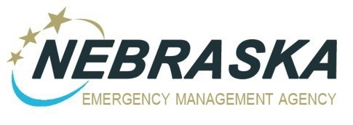
Registration Deadline is August 19

